Basics of java *(for Beginners level.)*

* Java is an object oriented programming language or modular programming language.
* Eg:-c++,python,c# etc.. also belong to the same category.
* History of java:-
* Founded by james gosling in 1991 and by there team sun micro systems.
* The project that they carried out was called green project
* The first version of java was launched in the year 1995 as hot java (web browser). Java 1.0
* Starting name of java was oak.
* In 2010 oracle acquired java.
* Features of java

1-compiled and interpreted

2-write once run anywhere(platform independent)

3-distributed language

4-multithreading

5-dynamic

6-object oriented language

Java compilation and running process:-

First.java(source code)

Compile (javac)

First.class(object code) (platform dependent)

Byte code (platform independent)

(java) interpreter(jvm-java virtual machine)

Excutable code.

Concepts of oops:-

1-class

2-objects public

3-encapsulation private

4-data abstraction protected

5-data hiding

6-inheritance compile time or static

7-polymorphism

8-data binding run time or

9-message passing dynamic

Smallest unit of program.

Java tokens operators

keywords punctuators identifiers literals

1-keywords-reserved words that have special meaning to the compiler.

* e.g- int int=10;
* int i=10;

2-identifiers-building blocks of a program.

* e.g-
* cannot start with digits.
* No special characters.
* Except 2 special characters. _ (underscore) and $ dollar sign.
* May have char,digit.

3- literals (constants)-are those data items that have fixed values.

|  |  |
| --- | --- |
| Integer | * Eg- 2 , 4, -2, -4 * -2.4 *wrong* |
| floating | * Eg-2.7, -9.4, +3.9 * 4 *wrong* |
| boolean | * Eg-true or false   Notjing else |
| null | * Eg-nothing   It indicates nothing. |
| Character | * Eg- ‘a’ , ‘b’…….’z’ |
| string | * Collection of characters.   Eg- “ram” |
|  |  |

4-separators-they help define the structure of a program.

e.g- () {} . , ;

5-operators-

* Relational- > , < ,>= ,<= , ==, !=
* Logical- &&, ||, ?:
* Arithmatic- * / % + -
* Prefix , postfix- x++,++x
* Bitwise-& | ^ << >>
* Datatypes:-

|  |  |  |
| --- | --- | --- |
| Datatype | size | Default value |
| Byte | 1 byte(8bits) | 0 |
| Short | 2 “ (16 bits) | 0 |
| Int | 4 “ (32 bits) | 0 |
| Long | 8 “ (64 bits) | 0l or 0L |
| Float | 4 “ (32 bits) | 0.0f or 0.0F |
| Double | 8 “ (64 bits) | 0.0d |
| Char | 2 “ (16 bits) | ‘\u0000’ |
| boolean | 1 “ (8 bits) | false |

Math classes:-

1-Math.sin()- to perform sine value of any angle.

Eg-Math.sin(90); - o/p-1.0

2-Math.cos()- similarly to perform cose value.

Double d=Math.cos(45)

*similarly we have Math.tan() and Math.log().

3-Math.sqrt()-for square root.

*most used*

Eg-Math.sqrt(16); o/p-4

4-Math.pow()- for putting power.

*very useful and is required at various places.*

Eg- Math.pow(3,2); o/p- 3^2=9

5-Math.abs- for absolute value.

Eg-Math.abs(-7.26); o/p-7.26

6-Math.min()- for minimum value

Eg-Math.min(10,2); o/p-2

7-Math.max()- for maximum value

Eg- Math.max(10,2); o/p-10

8-Math.ceil()-

eg- Math.ceil(7.26); o/p-8.0

Math.ceil(-4.26); o/p-4.0

9-Math.rint()-

Eg-Math.rint(7.26); o/p-7.0

Math.rint(7.67); o/p-8.0

*/ also there are many more methods to perform mathematical operations but we are not discussing them all.. some of the useful and frequently used methods are discussed above. */

Input in java:-

There are 4 types to input in java:-

1. DataInputStreamclass- java.io

Eg-

import java.io.*;

class Input

{

public static void main(String arg[])throws IOException

{

DataInputStream ob=new DataInputStream(System.in);

System.out.println(“enter name and age”);

String n=ob.readLine();

Int age=Integer.parseInt(ob.readLine());

System.out.println(“name=”+ n);

System.out.println(“age=”+age);

}

}

1. BufferedReader class:- java.io

Eg-

import java.io.*;

class Sum

{

public static void main(String arg[])throws IOException

{

InputStreamReader isr=new InputStreamReader(System.in);

BufferedReader br=new BufferedReader(isr);

System.out.println("enter a number");

int a=Integer.parseInt(br.readLine());

int b=Integer.parseInt(br.readLine());

int sum=a+b;

System.out.println("sum="+sum);

}

}

1. Scanner class:- java.util

import java.util.*;

class Input

{

public static void main(String arg[])

{

Scanner sc=new Scanner(System.in);

System.out.println(“enter name and age”);

String n=sc.nextLine();

Int age=sc.nextLine();

System.out.println(“name=”+ n);

System.out.println(“age=”+age);

}

}

|  |  |
| --- | --- |
|  |  |
|

|  |  |
| --- | --- |
| Datatype | Input |
| byte | byte b=Sc.nextByte(); |
| Short | Short s=Sc.nextShort(); |
| int | int x=Sc.nextInt(); |
| double | double y=sc.nextDouble(); |
| long | long k=Sc.nextLong(); |
| float | float p=Sc.nextFloat(); |
| A word | String a=Sc.next(); |
| Multiple words | String s=Sc.nextLine(); |
| char | char ch=Sc.next().charAt(0); |
|  |  |

**note- starting letter of keywords and data types should be small letter.

4-Command line argument:-

Class prg

{

Public static void main(String arg[])

{

String n=arg[0];

Int age=integer.parseInt(arg[1]);

Sopln(“name=”+n);

Sopln(“age=”+age);

}

}

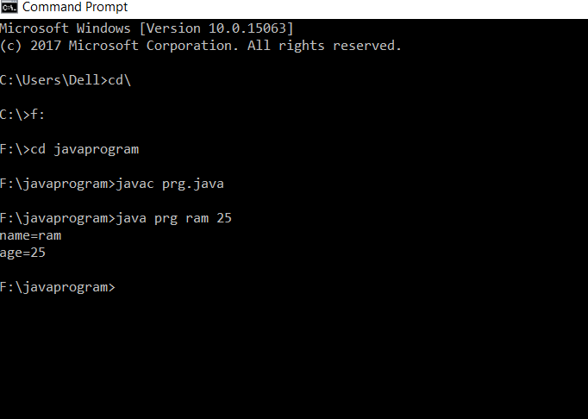

If we talk about Pure java, it is operated through command prompt only. As far as I have acknowleged.

* Various uses of java programming language:-

It is popular language and it is used to develop all kinds of applications.

* Web applications
* Mobile applications
* Embedded systems
* Web servers and applications servers
* Scientific applications
* Desktop GUI applications etc..,
* Conclusion:-

In conclusion, I would like to say that the information that I have furnished above is enough for the beginners who are looking forward to code with java programming as there weapon.

Basic information about the particular programming language+ learning how to input is the key and also the structure of program.

Now, you can start coding basic programs with the given information/data.

Thankyou.

Hactelligence member.

*Sameer srivastava*